**Exercise 2: Verifying Interactions**

**Scenario:**

**You need to ensure that a method is called with specific arguments.**

**Steps:**

1. **Create a mock object.**

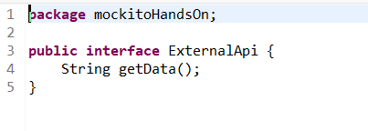

1. **Call the method with specific arguments.**

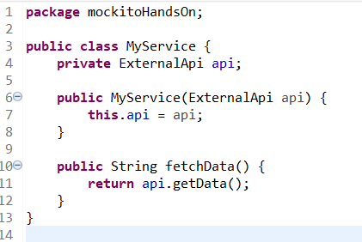

1. **Verify the interaction.**

